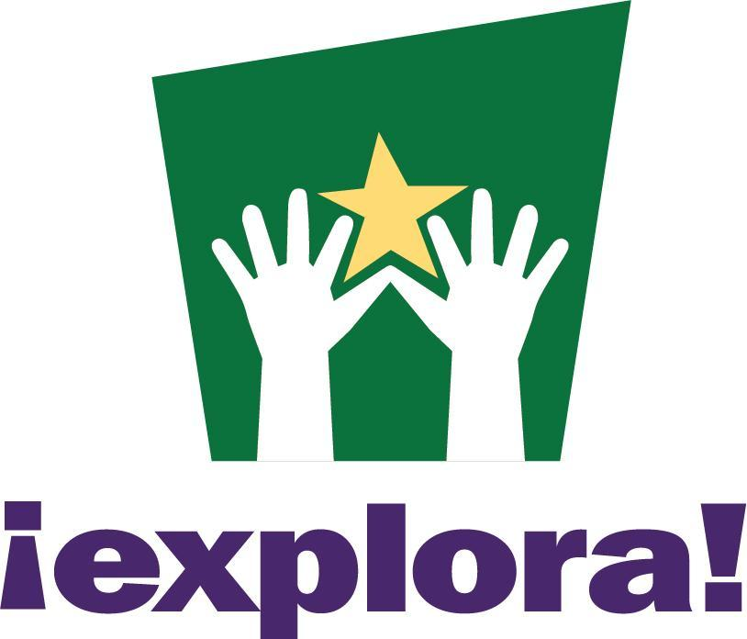

Job Description

Group: Education
Position: STEAM Professional Liaison
Reports to: Director of Education
FLSA status: 40 hours per week (full time); exempt (salaried): on-site
Pay range: $46,000-$50,000/year with 100% employer-paid health insurance premiums
and additional benefits

Send cover letter and resume to Tara Henderson, Director of Education, thenderson@explora.us.

Position Summary:
The STEAM Professional Liaison is responsible for developing relationships with a diversity of professionals who work in STEAM (science, technology, engineering, art, math) fields and developing programs that support broader impacts, community engagement, and career pathways. The STEAM Professional Liaison works closely with the Director of Education along with Visitor Experience, X Studio, and Exhibits staff to incorporate the knowledge and expertise of the STEAM professionals as part of programs, exhibitions, and events. The STEAM Professional Liaison takes a big picture approach to the integration of STEAM professionals in programs, exhibitions, and events; develops and schedules science communication training programs to support the STEAM professionals to share their work with the general public. Responsible for developing relationships with schools and other community partners in alignment of Explora's strategic plan. Responsible for working with the Direction of Education for meeting program revenue and attendance goals. Coordinates with other managers for smooth daily operations. Develops curriculum and facilitates classroom programs for all ages. Facilitates and develops professional development for STEAM professionals as well as teachers. Also responsible for working on the exhibit floor and interacting with visitors. Manage both small and large scale projects with community partners, in order to work systematically to affect change. May be assigned other responsibilities as needed by the Director of Education.

Essential Duties and Responsibilities:
- Responsible for developing relationships with a diversity of professionals who work in STEAM (science, technology, engineering, art, math) fields to embed STEAM in Explora programs, exhibitions, exhibits, and events.
- Responsible for leading a cross department group to develop programs that support broader impacts, community engagement, and career pathways.
- Develop and maintain relationships among Explora and schools/districts statewide. Develop and maintain community connections for outreach and partnerships: community centers, day care centers, senior centers, scouting groups, higher education organizations, etc.
- Schedule and conduct professional development workshops for STEAM professionals on topics, like Explora’s pedagogy, science communication, and other topics pertinent to quality program facilitation.
- Develop and facilitate professional development workshops for STEAM professionals, teachers, librarians, out-of-school time staff, etc.
- Develop and facilitate experiential programs in science, technology, engineering, math, and art for diverse audiences.
- Collaborate with other educators in development of programs and maintenance of program materials.
- Participate in outreach around the state at community centers, senior centers, festivals, etc.
- Work with Director Education to meet budget and attendance goals.
- Work with the Director of Education to ensure programs meet intended objectives and outcomes.
- Work on committees that cross Explora departments.
- Deal appropriately with visitor comments/concerns.
- Comply with all operational policies, especially those involving the safety of fellow workers, volunteers, and visitors.
- Demonstrate excellent customer service at all times.
- Interact well with all levels of management, peers, co-workers, suppliers, and vendors. Coordinate with other groups as needed.
- Maintain a current and valid driver’s license to perform work duties.
- Work weekends and late hours, as business needs dictate.

Minimum Qualifications:
- Bachelor’s degree in field of emphasis (e.g. chemistry, physics, biology, engineering). Master’s or doctorate degree preferred.
- Experience working in an educational institution or equivalent background performing similar duties. An equivalent combination of education and/or experience may be substituted, as long as it directly relates to the essential duties and responsibilities.
- Demonstrate an active interest in science, technology and art, with an ability to communicate and facilitate exhibits thoroughly and effectively.
- Must be able to deliver effective group presentations and communicate clearly in written form.
- Must demonstrate excellent supervision, leadership, organizational, and planning skills
- The ability to speak Spanish is desirable.

Functional Work Characteristics:
- Requires standing and/or walking, with regular need to perform physical actions that include, sitting, stooping, kneeling, crouching, reaching, handling materials, pulling, carrying, and pushing.
- May occasionally require lifting of various materials and equipment to a maximum of 50 pounds.
- Facility may expose employee to loud noise levels, temperature changes, and physical obstacles.
- Must pass a federal background check upon employment.

Work Conditions:
- Most essential duties are performed in a museum and office environment with exposure to a variety of business equipment and other pertinent materials normally found in this type of work setting.
- Museum facilities may expose incumbent to high noise levels, temperature changes, liquid nitrogen, helium gas, electrical exposure, unpredictable ventilation, dust, and physical obstacles.
- Work is normally performed in an area of limited privacy.

Employee Acknowledgement:
This Job description is intended to convey information essential to understanding the scope of this position, it is not intended to be an exhaustive list of skills, efforts, duties, responsibilities, or working conditions associated with the position. Explora maintains the right to augment or delete duties and responsibilities as business needs dictate.

I have rea I have read and understand the entire contents of this job description, including the work demands and expectations of this position. I understand that my employment at Explora is employment “at will” and may be concluded at the convenience of Explora Science Center and Children’s Museum of Albuquerque. I am aware of my right to notify my employer of any reasonable accommodation that may be necessary to perform this work. I further believe to the best of my knowledge that I am able to perform these duties and responsibilities. If I determine that an accommodation may be necessary at a later date, I shall notify my employer. I understand that my employer maintains certain rights as well under the Americans with Disabilities Act (ADA).

Employee Signature |  | Date signed
Director Signature |  | Date signed

Explora Science Center & Children’s Museum is an equal opportunity employer

